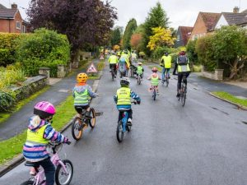

Whitchurch Primary School’s first Bike Bus 31.3.23
Meeting this evening 6:30 pm at the school to discuss arrangements.
All welcome.

Questions to ask are:
1. How many children can one adult safely look after on the ride?
2. If the adult has volunteered as a Chaperone, what happens to the child/children they are responsible for?
3. Think of Who has ultimate responsibility if the child has any issues such as a puncture, drop their school bag etc?
4. Will the organisers coordinate each child having an allocated adult, or will it be the responsibility of the parents.

Choose a time and start point that has enough space for everyone to meet and won’t obstruct others. Make sure to give enough time to get to school – cycling in a group with children takes longer than cycling on your own.

Hungry Horse Carpark

Look for routes with left turns

Avoid busy main roads - we will use Merthyr Rd for a couple of minutes

Include multiple bike bus-stops and times - one for the future

Will helmets and hi-vis be required? Helmets should be mandatory look for our high vis vests

Do you need insurance? Many bike buses start without. As some get bigger, they decide to get insurance. Another benefit of our FRideDays Bike Bus training is that if you’re an official Sustrans volunteer, your bike bus is automatically insured. Or, you can get insurance as an affilliated Cycling UK group.

Take your new route for a spin. Go for a test ride at the time you’ll be using the route to make sure they’re not too busy for the bike bus.

Brief your bike bus to ride together and slowly by following the volunteers and not spreading out or falling behind the back marker. Explain they should talk to each other, pass messages to and from the leaders, and be aware of other members riding closely to them. (Remember: you might need to cycle more slowly than you would on your own to make sure the group stays together.)

Refresh everyone on the rules of the road, like riding on the left and giving way to pedestrians. If there are any extra precautions like roadworks, potholes, or bad weather, let everyone know. Remind adults that they’re responsible for their child.

Explain how to tell a leader if there’s a problem. For example: shout out ‘mechanical!’ and ask everyone else to pass it up the line.

Remind everyone to have fun! It’s just a bike ride!

#FridayWeCycle and tag @FRideDaysbb

