
Pupil Development Grant 26-27
Whitchurch Primary School

This statement details our school’s use of the PDG for the 2026 to 2027 academic year.

It outlines our strategy, how we intend to spend the funding in this academic year and the effect that last year’s spending had within our school.

School Overview

Detail | Data
School name | Whitchurch Primary School
Number of learners in school (September 2025) | 54
Proportion (%) of PDG eligible learners | 9%
Date this statement was published | 22.9.26
Date on which it will be reviewed | Termly
Statement authorised by | K Watkins
PDG Lead | K Watkins
Governor Lead | S Rowlands & R Karamouzis

Funding Overview

Detail | Amount
PDG funding allocation this academic year (March 26-March 27) | £78,630.00
Total budget for this academic year | £78,630.00

Part A: Strategy Plan

Statement of intent

Key objectives:
- Improved outcomes of FSM pupils and vulnerable learners.
- Improved levels of attendance of targeted pupils.
- FSM and vulnerable learners access wellbeing intervention, including Thrive, to support social and emotional development enabling increased engagement in learning.
- FSM and vulnerable learners access high quality bespoke interventions in literacy and numeracy to secure progress towards realising their expected outcomes.
- Offer provision to enrichment activities to further support engagement and development of skills and talents, life opportunities e.g. music tuition, club attendance, pupil voice groups, residential trips.
The purpose of the Pupil Development Grant (PDG) funding at Whitchurch Primary is to make a lasting impact on outcomes for disadvantaged learners. The third enabling objective from the national mission is to ensure we have strong and inclusive schools committed to excellence, equity and wellbeing and it is essential that there is a whole school approach to improving outcomes for pupils entitled to free school meals.

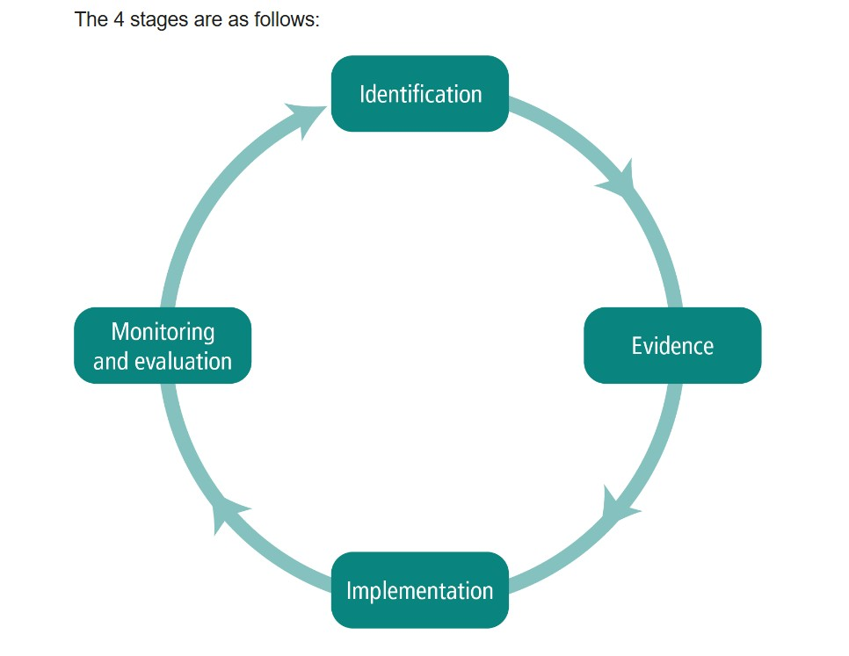

Intended outcomes

This explains the outcomes we are aiming for by the end of our current strategy plan, and how we will measure whether they have been achieved.
Intended outcome | Success criteria
1. Improved attendance and narrowing the gap between FSM and non  FSM attendance | Improved overall % attendance compared to 25-26.  Narrow the gap for FSM and non FSM attendance.  Implement Inclusive Attendance Framework and 3 tier system to implement quicker support networks and reduce persistent absenteeism, especially for FSM pupils.  Reduced lateness and holiday absence for FSM and vulnerable pupils  Individual families engage with staff understanding the importance of being in school every day.  Partnership working with external services to provide support mechanisms for families to secure attendance. For example:  Individual families engage in targeted family support e.g. Attendance Office, ALNCo/FEO, Team around Child attendance meetings, Cardiff Family Gateway and Early Help services and health professionals such as nurses and health visitors.
2. Learning outcomes; FSM and vulnerable pupils make expected progress in literacy (speaking and listening, reading and writing) | Progress from initial starting points (assessment data and pupil progress meetings)  Improved Speech and language links data.  Improved Wellcomm data.  Keep up phonics/ CLIP/ 1:1 reading- pupils catch up and maintain progress at age expected level, and improve fluency and comprehension skills.  Quality daily reading and additional 1:1 reading improves enjoyment of reading and reading ethos.  Improved home and school reading relationships.  Parents/carers attend reading workshops with their children.
3. Learning outcomes; FSM and vulnerable pupils make expected progress | Progress from initial starting points (assessment data and pupil progress meetings).
in mathematics, especially in developing  and applying fluency  skills | Daily quality math fluency lessons for all pupils and targeted pre teach maths and fluency maths sessions show improved confidence and ability to apply fluency and strategic competency skills to procedural and reasoning activities.  Improved self esteem in maths as shown in engagement in lessons and interventions.
4. Wellbeing; Improved social and emotional wellbeing ensuring engagement in learning | All staff have greater confidence in supporting pupils' emotional health and wellbeing through implementing PACE approach and trained in level 1 Trauma Informed TIPSS practices.  Pupil questionnaires and PASS data shows that pupils feel safe and happy in a school environment.  Pupils increase levels of self esteem.  Improved understanding of one's own and emotions of others and able to regulate one's own emotions.  Develop strategies to promote their own mental health and wellbeing.  Thrive profiles show progress.  Successful engagement in Jigsaw, RSE and Thrive sessions.  Successful engagement in wider areas of school life e.g. breaktimes, pupil voice groups, clubs and teams.  Successful implementation of wider therapeutic services; ELSA, Baxter Project and Play Therapy.
5. Opportunities to access and participate in wider  life skills and opportunities | High number of FSM and vulnerable pupils attending lunchtime and after school clubs, accessing music tuition, joining sports teams, attending residential trips.  Membership and involvement in pupil voice groups.

Activity in this academic year

This details how we intend to spend our PDG this academic year to address the challenges listed above.
• Bespoke wellbeing interventions implemented to support individual social and emotional needs. This will include; ELSA, Thrive support and lunchtime wellbeing clubs. • Extend release time for ALNCo to support vulnerable families and Family engagement activities and work to build relationships, and help reduce barriers to learning for vulnerable families and pupils
- Bespoke therapeutic support through the Baxter Project and Play Therapist support for targeted pupils.
- Small group or 1-1 mastery tuition to consolidate basic skills in phonics, speech and language, reading, writing and number.
- Use of a support staff to lead reading interventions with a focus upon decoding and comprehension through CLIP.
- Use of support staff to implement writing interventions through CLIP.
- Speech and language and Wellcomm bespoke and 1:1 support.
- Time for ELSA and THRIVE staff to attend network meetings and updated training.
- Professional learning for interventions e.g. Speech and language links, Phonological Awareness Training, Popat, CLIP reading and writing.
- Support for the attendance team to liaise with the School Attendance officer and attend Team Around Child meetings and undertake detailed attendance analysis.
- Ensuring additional opportunities such as music, residential trips, pupil voice group representation undertaken for all pupils.
- Loaning high quality reading books and learning to read books to ensure provision is free and accessible to all learners.

Learning and teaching / Wellbeing

Budgeted cost: £72,630
Activity | Evidence that supports this approach
1-1 or small group support | Additional staff to support high quality teaching and learning through bespoke interventions for identified learners – intervention data. Pupil progress data.
ALNCo/FEO work | Pupil progress data, attendance data, pupil and parent questionnaires
Therapeutic Therapy; Baxter Dog Therapy and Play Therapy | Exit and entrance questionnaires  Pupil Questionnaires, PASS, engagement in lessons, attendance data
Wellbeing groups and lunchtime clubs | Pupil questionnaires. PASS. Engagement in lessons. Pupil progress data
CLIP reading and writing  1:1 reading and writing  Phonics keep up interventions | Intervention data  Pupil progress data for literacy  Engagement in reading  Fluency and comprehension skills data
Reading books | Equality of provision  Enjoyment of reading  Reading progress and pupil progress meetings data
Maths | Intervention data
Pupil progress data
Engagement in lessons
Speech and language | Wellcomm data  Speech and language links data
Wider provision and enrichment | Attendance and participation in:  Breakfast club  Lunchtime/ after school clubs and sports  Music provision/ Choir  Attendance of trips and residentials  Pupil Voice Group Participation

Community Focused Schools (to include: (i) building strong partnerships with families; (ii) responding to the needs of the community; (iii) collaborating with other services)

Budgeted cost: £ 1000 (Attendance TAC meetings, resources for reading workshops)
Activity | Evidence that supports this approach
Well attended Parent Engagement sessions and workshops | Parent evenings attended  Parents and carers attend reading workshops and curriculum celebration events
Engagement with external agencies | Attendance to TAC meetings, meetings with school nurse, meetings with ALNCo  Number of Early Help referrals.  Attendance and completion of courses through Cardiff Adult Learning

Wider strategies (for example and where applicable, Health and Well-being, Curriculum and Qualifications, Leadership and Raising Aspirations)

Budgeted cost: £ 5000
Activity | Evidence that supports this approach
Thrive training | Thrive data
ELSA training | Thrive data (used to support ELSA planning)
CLIP training | Phonics data  Reading data
 | Writing progress
TIPSS school EP training | PASS and wellbeing questionnaires- pupils  Thrive data
Speech and Language links  training | Speech and Language Link data
Bristol Literacy Hub | Reading data  Writing progress
AoLE literacy team | Coaching and mentoring: impact on teaching and learning (Performance Management)  Pupil data; oracy, reading and writing
Wider experiences | Club data  Music / choir data  Residentials and trips attendance  Participation and data of pupil voice groups

Part B: Review of outcomes in the previous academic year

PDG outcomes

This details the impact that our PDG activity had on pupils in the 2025 to 2026 academic year:
Activity | Impact
To effectively support the mental, emotional and social wellbeing of all pupils | Enhancing Thrive, Nurture provision and other interventions such as ‘ELSA’ to support and enhance pupil well-being.  Providing additional staffing & resources at break/lunchtimes in order to engage pupils in meaningful activities, thus promoting well-being and self-esteem  12 FSM pupils needed Thrive action plans and interventions. 10 of these pupils made progress. Two pupils have needed significant support from wider services and this will continue in 26-27.  Additional members of staff trained to deliver ELSA; 3 further staff members trained to ensure capacity is met. School now has 8 Thrive teachers, and 4 ELSA trained staff.
Literacy and numeracy | Nearly all FSM pupils achieved above 85 in Welsh Government tests for years 2 to 6, with many achieving above 100, showing positive impact of interventions.  A high proportion of FSM and vulnerable pupils receive additional interventions for maths, literacy and speech and language. Intervention data shows that nearly all these pupils made progress in interventions and WGT.
Attendance | Overall School Attendance increased from 94.4% to 94.7%  Free School Meal Attendance remained in line with previous year at 89.1% and remains a key focus of SIP priorities next academic year.
Wider enrichment | Supplementing the funding of school visitors, therefore removing barriers to access to enhanced opportunities  Supplementing the cost of music tuition, trips, after school clubs and residential trips to enable all children to participate.

Externally provided programmes

Please include the names of any programmes that you purchased in the previous academic year. This will help us identify which ones are popular in Wales.
Programme | Provider
Wellbeing | ELSA  Thrive Approach
Numbots and TTRS | Maths Circle
Unlocking Letters and Sounds | Ransom
Seesaw | Seesaw Education
Bristol University | Jane Carter and Cerys Stevens
CSC training | Welsh Government

